[WOBI-5] Logo and the tab תכולה goes over the sentence Created: 15/Feb/24 Updated: 26/Feb/24
Status: | To Do
Project: | Wobi

Type: | Bug | Priority: | High
Reporter: | Tomer Darmon | Assignee: | Tomer Darmon
Environment: | Browser :  Chrome Version 121.0.6167.140  Firefox Version 122.0.1  Microsoft Edge Version 121.0.2277.106

Attachments: | 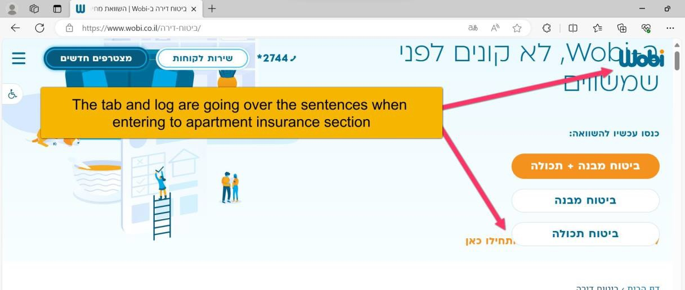
Severity: | S5- Low

Description
Steps to Reproduce :
- Enter to Microsoft Edge to URL www.wobi.co.il
- Press on the tab דירה ביטוח
- In the new page you will see the word תכולה goes over the sentence
Actual Result: The word תכולה is going on top of the sentence and the logo is spread all around above it.
Expected Result: The word תכולה won´t go over the sentence and same with the logo on Microsoft Edge

Comments
Comment by Tomer Darmon [ 15/Feb/24 ] On Microsoft Edge you can see that the logo is going over the other sentences and also the word תכולה is going over a sentence which you will also see that bug on Chrome and Firefox but not with the logo problem which was only in Microsoft Edge.

20

